SCIENCE
Our BIG QUESTION for Science this half term is: Why does my heart beat?
Our key questions are:
- What does a heart look like inside and out?
- Where is the heart and what is its function?
- How does the heart function?
- What is the effect of exercise on the heart and circulatory system?
- How are nutrients and oxygen circulated in our body?
- What is blood made from?
- How do we keep our hearts healthy?

á
GEOGRAPHY

Our BIG QUESTION this half term will be: Why does population change?
Key questions will include:
- How is the global population changing?
- What are birth and death rates?
- Why do people migrate?
- How is climate change impacting the population?
- How is population impacting our environment?

OWLS CLASS
Autumn Term 2

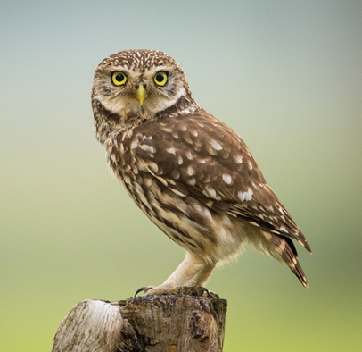
ENGLISH
Our main class reader will be: Wisp – A story of hope by Zana Frailon and Grahame Baker Smith
In writing we will focus on :
Fiction to entertain – poetry
Non-Fiction – non-chronological report

There will be emphasis once more on ensuring all pupils are joining their handwriting to improve the presentation and fluency of written work.
ART
Art will be linked to the festive season – cards, calendars and decorations!

MUSIC
This term we will be preparing songs for the Christmas performance as well as some traditional carols for our church service.

PLEASE REMEMBER:
- Reading book + Home Reading Record each day (line day, is where we record the number of ‘home’ reads each Tuesday)
- Homework books each Tuesday

MON/FRI LEARNING
This term we will be focussing on :
PSHE
- The theme for this half term’s work will be: Difference and Diversity.

English:
- Grammar and punctuation worked linked to the writing focus in English
Mathematics:
- Length
Design & Technology
Food technology – Middle Eastern food such as Tabbouleh, hummus. Falafel, spiced fritters
MATHEMATICS
The class falls into two main age groups and will be taught separately. The main units this term are:
UKS2 – Continuation of Understanding hundredths as part of a whole
- Using knowledge of decimals to solve problems in different contexts
LKS2 – Complete the review of column subtraction
Securing place value to 1000

As always, there will be emphasis on TIMES TABLES! and there is also a push for fluency in number bonds to 10, 20, 100 and beyond.
RELIGIOUS EDUCATION

Our RE themes this term will be: What can be done to reduce racism? Can religion help?
We will also be preparing for our Family Christmas service at St. Edmunds.

COMPUTING
Creating media – video.

