Understanding the World
- Bonfire night
- Look at the changes in the weather, what’s happening to the leaves on the trees.
- Talk about Remembrance Day
- Learn about Diwali
- Why we celebrate Christmas
- Hibernation

á
Art and Design
- Firework painting
- Remembrance Sunday poppy handprints
- Seasonal Art
- Rangoli Patterns
- Christmas decorations
- Mehndi Henna designs

Hedgehogs Class

Autumn Term 2

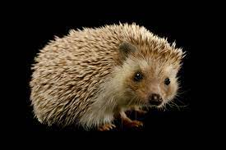

Music
This term we will be preparing and performing songs for the Christmas nativity play. We will be:
- Singing together as a group
- ·Understanding rhythm and percussion
- ·Listening and responding to music with our bodies
Oak Academy
Maths
- Numbers within 15
- Grouping and sharing
- Numbers within 20

Number bonds 1-5
Measurement
2D and 3D shapes
KIRFS – subitise to 5

Physical
P.E – with Mrs Wilson

Gross Motor – running, skipping, climbing, throwing, catching, yoga
Fine Motor – pencil control, cutting, sticking, dough disco

Literacy

Little Wandle – Phase 2 and 3
- Initial sounds
- Write simple CVC words
- The story of Guy Fawkes
- The story of Diwali
- The Christmas Story

Please remember to bring to school:

- Your school reading book and book bag.
- A water bottle.

At home please:
- Practise your letter sounds
- Share reading book

Class Reads

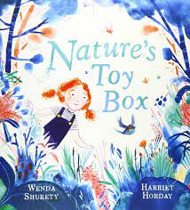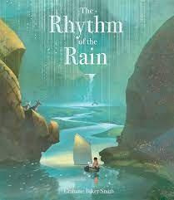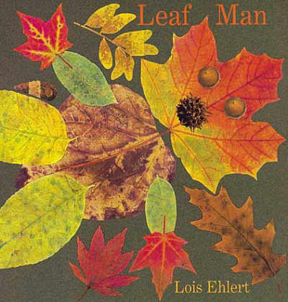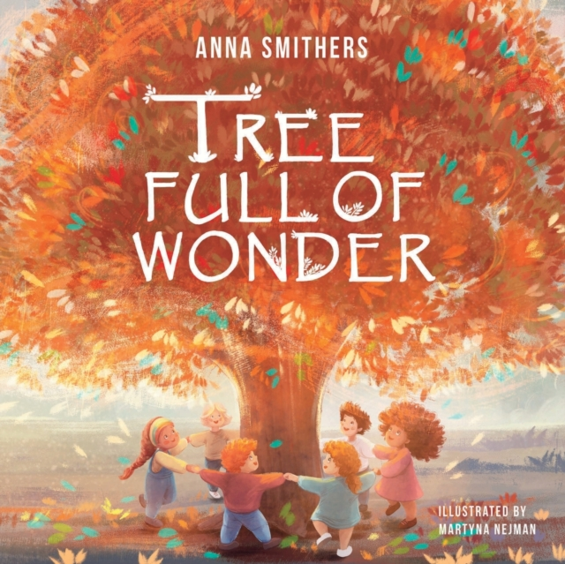

PSE
- School rules
- Taking turns
- Listening to others feelings
- Choose it, use it, put it away!
- Staying safe.
R.E.
DCC Syllabus
Believing-
Which people are special and why?

