Art and Design
- 3D designs – how to make an L-Brace join
- Make snow dough
- Explore Chinese New Year
- Kandinsky Trees
- Create the Arctic in tuff tray
- Make Owl shaped snacks

Understanding the World
- This time of year is Winter
- Changes in states of matter – frozen, melting
- Where do polar bears come from?
- Looking at the globe and maps
- Where is the Arctic?
- Explore Chinese New Year
- Find out facts about owls

á
Hedgehogs Class

Spring Term 1

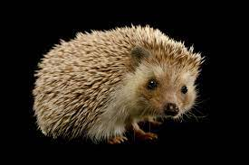
Maths – Oak Academy
- Numbers within 20
- Doubling and halving
- Addition and Subtraction within 20

KIRFS
- I can partition numbers to 5 (10) into two groups.
Vocab – add, plus, equals, altogether, part whole.

ICT Games/Topmarks/BBC Bitesize
AdaptedMind Math
https://www.AdaptedMind.com › free › math

Music
- Rhyming
- Clapping
- Music from different cultures
- Children will know a range of Nursery Rhymes

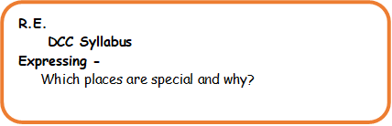

Please remember to bring to school:

- Your school reading book and book bag.
- A water bottle.

At home please:
- Read your book
- Practise your letter sounds

Physical
P.E – with Mrs Wilson

Gross Motor – running, skipping, climbing, throwing, catching, yoga
Fine Motor – pencil control, cutting, sticking, dough disco, knife skills for Owl snacks

Literacy
- Draw recognisable characters
- Write simple labels/ captions
- Start and write CVC words and taught tricky words.
- Little Wandle Phase 3
- Blend known sounds in words

PSE
- School rules
- Make the right choice
- Talk about key events in stories
- Ask ‘when’ questions
- Use appropriate vocabulary when describing Owls

Class Reads



