EYFS Long-Term Plan

Subject | Autumn 1 | Autumn 2 | Spring 1 | Spring 2 | Summer 1 | Summer 2
 | Marvellous Me! | Nature’s Toybox | Tell me a story | Circle of Life | I would like to be.. | Wonderful World
 | 2 year old: | 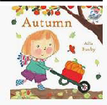  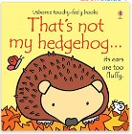  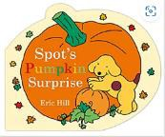  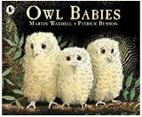  2 Year Olds:  Nursery:  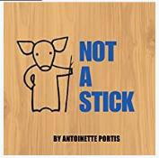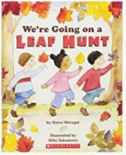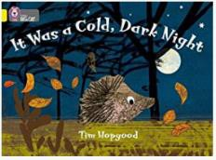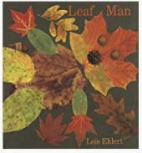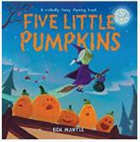  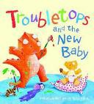  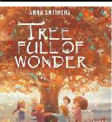  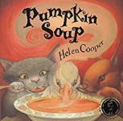  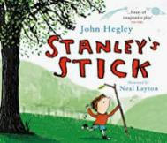  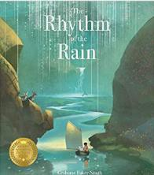  Reception:  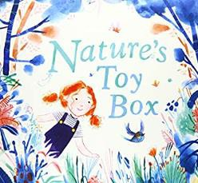  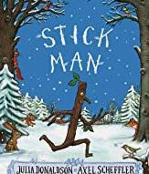  All EYFS: | 2 Year Olds  Nursery Rhymes – Twinkle Twinkle, Incy Wincy, Grand Old Duke of York, Humpty Dumpty,  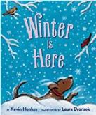  Baa Baa Black Sheep  Nursery  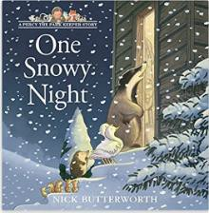  Nursery and Reception  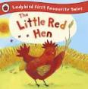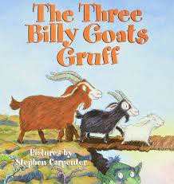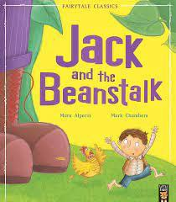  Reception:  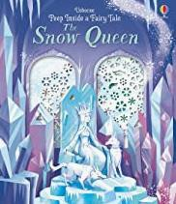  Last 2 weeks – children's choice | 2 year old:  Titch, Round and Round the Garden, Plant the tiny seed, My Garden.  Nursery:  Hungry Caterpillar, Jasper’s Beanstalk, Painting a Rainbow, The Hidden Rainbow, Oliver’s vegetables, From the Garden – counting book, The Cautious Caterpillar.  Reception:  The Tiny seed, Jack and the Beanstalk. Oliver’s fruit, Tad, non –fiction farm books from library | 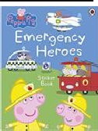  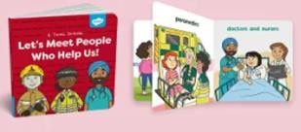  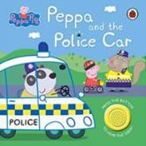  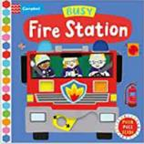  2 year old  Nursery:  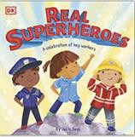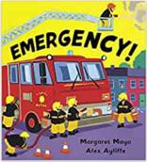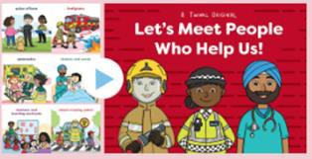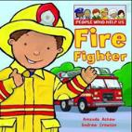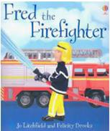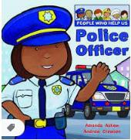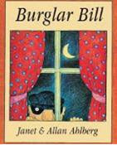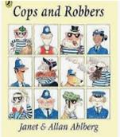  Reception:  The Queen’s knickers, Superworm, Non Fiction books linked to vets, librarians, Emergency services, Mog and the V.E.T | 2 year old:  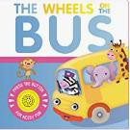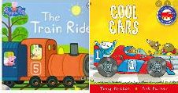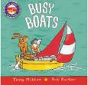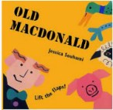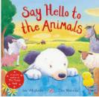  Nursery:  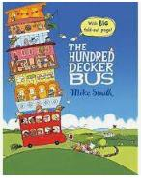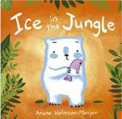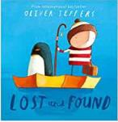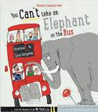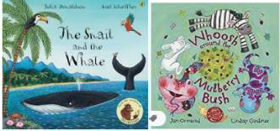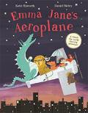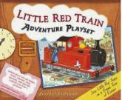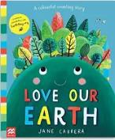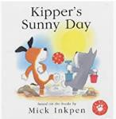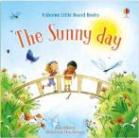  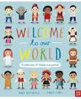  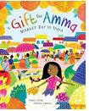  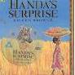    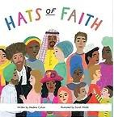  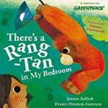  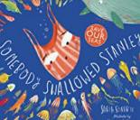    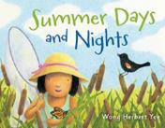  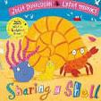  Reception:
 | 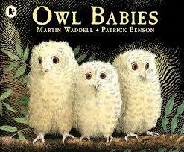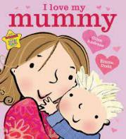
 | 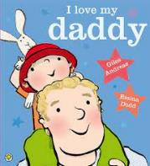
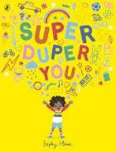
Nursery:
 | 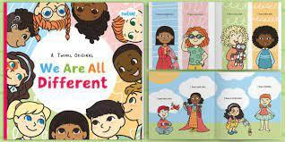
Core text
 | 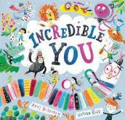
 | 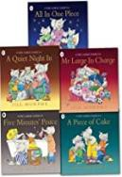
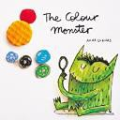
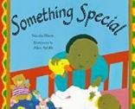
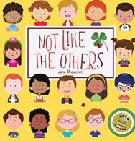
Reception:
 | 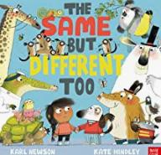
 | 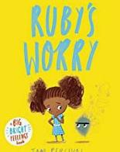

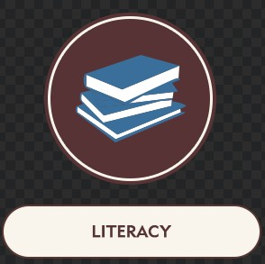 | Children to engage in mark  making | I can talk about what my pictures  mean | I can draw some recognisable pictures | I can write some letters in my name | I can write my name with some recognisable letter shapes. | I can write my name with recognisable letter shapes.
 | Children will know how to draw horizontal lines. | Children will know how to draw vertical lines. | I can the initial sounds letters in my name.  Children will know how to draw circles. | I am writing in my play and role-  play  Children will know how to draw diagonal lines. | I can write some letter shapes in my mark making.  I can talk about my marks in detail. | I can give purpose and meaning to my mark making.  II can write some initial sounds in words.
 | Name Writing | Mark making  Identifying and writing initial sounds  Write familiar cvc words such as cat and dog | Writing cvc words and cvcc words Writing labels  Write taught tricky words | Writing cvc words and cvcc words Write some taught diagraphs Writing labels  Writing a short phrase | Form lower case letter correctly Write a short sentence | Forming capital letters correctly Know how to read what they have written and check it makes sense.
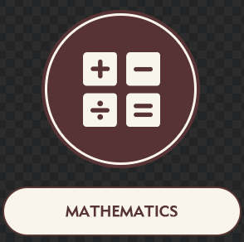 | Nursery
 | Exploring and comparing numbers through number rhymes and songs
 | Subitise
 | Explore and compare the composition of number
 | Investigate shape, patterns and spatial awareness
 | Reception |  | Number and place value to 10 Number bonds to 10  Addition  Doubling, sharing and grouping Measurement 2D and 3D shapes Time  Spatial reasoning Odd and Even |  | Number and place value to 10/20 Number and place value to 10/20 Addition and subtraction  Spatial Reasoning: Match, Rotate & Manipulate Spatial Reasoning: Mapping
 | Number and place value to 5/10
 | More/less
 | Measurement
 | Repeating patterns
 | Sorting
 | Number bonds to 5
 | 1 more/1 less
 | 2D and 3D shapes
 |  | Autumn
 | Ourselves | Diwali | Winter | Spring |  | Summer
 | Senses | Bonfire Night  Christmas | Farms  Past and Present - Castles | Growing plants  Mother’s Day | Jobs/Occupations | Different places around the  world
 |  | Christmas Past and Present | Chinese New Year | Easter |  | Seaside
 | Self-portraits using a range of mediums. | Seasonal art using natural materials  Observational drawings  Children to learn songs linked to Christmas | 3D art and design linked to stories  Chinese New Year art | Observational drawings of plants and animals | Imaginative play linked to occupations | Art and design linked to different artists.  Art linked to around the world
Throughout the year children will:
- Learn to speak with confidence during circle/carpet times Learn to listen and respond appropriately with relevant comments, questions or actions.
  - Have opportunities to have conversations and develop vocal sound formation in doing this.
  - To respond to instructions and directions through adult initiated/led and child led activities.
- Use appropriate story language to re-enact/re-tell simple and familiar stories Learn new vocabulary relating to topics.

 | Throughout the year children will:  - Hold a conversation back and forth with familiar adults and peers.  - Can listen attentively in a range of situations, asking relevant questions to clarify.  - Use new vocabulary in different conversations to share their own ideas.  - Express ideas and feelings, making use of past, present and future tense.
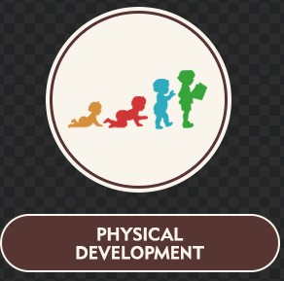 | Throughout the year children will:  Develop their gross motor and fine motor skills through progressive ‘Squiggle Whilst You Wiggle’ and ‘Dough Disco’ programmes  - Move confidently in a range of different ways on different levels at varying speeds during multi-skills and outdoor provision.  - Build up confidence when balancing during activities and outdoor provision.  - To be confident when mark making, holding tools appropriately and practicing name writing throughout the whole year.
 | Reception  Fundamentals (speed and direction) | Reception  Dance | Reception Gymnastics | Reception Fundamentals (types of passing, catching and ball skills) | Reception  Team games | Reception Athletics – Sports Day Link
 | Throughout the year the children will:  - Become confident separating from their main carers.  - Form relationships with familiar adults and peers.  - Interact and play with peers, taking turns and sharing fairly.  - Work on their self-regulation skills with the support of co-regulation from a familiar adult.  - Become independent in their self-help skills, including, the snack area, getting their belonging and resources, and going to the toilet.  - Begin to understand what it is to be healthy and what they can do to stay healthy.
Throughout the year the children will:
- Begin to regulate their own emotions and recognise different emotions in others.
  - Form positive relationships with familiar adults in school and their peers.
- Can manage their own basic hygiene needs, including, going to the toilet independently and understanding the importance of healthy eating.
  - Can work and play cooperatively and take turns with others.
    - Can follow rules and routines established in my classroom.
- Children can work towards a simple goal, showing resilience and perseverance in the face of a challenge.

