HISTORY

Our BIG QUESTION this half term will be: Who were the Ancient Greeks and what have we learned from them?
Key questions will include:
- Who were the Ancient Greeks and when did they live?
- Who lived on Mount Olympus?
- How was Ancient Greece governed?
- Did the Ancient Greeks give us democracy?
- How do the Ancient Greek philosophers influence us today?
SCIENCE

Our BIG QUESTION for Science this half term is: How and why do things move?
Our key questions are:
- What are examples of mechanisms?
- How do levers impact on load and effort used?
- What are the three laws of motion?
- What are forces?
- What is gravity and air resistance?
- What is water resistance?

á
OWLS CLASS
Autumn Term 1

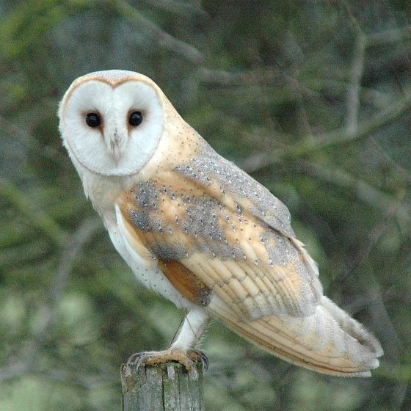
MUSIC
This term we will be preparing and performing songs for the Harvest Service.
We will be also be learning about Blues. This will include:
- The history of the Blues
- Playing a chord
- The 12-bar Blues

ENGLISH
Our main class reader will be: Who let the Gods out? by Maz Evans and Explore Ancient Greeks by Jane Bingham
In writing we will focus on :
Fiction to entertain – Settings to create atmosphere.
- Using the senses to describe –‘paint a picture’ – of a setting to the reader
Non-Fiction – Instructions and Non chronological report
- These will link to the History work on Ancient Greeks

There will be emphasis once more on ensuring all pupils are joining their handwriting to improve the presentation and fluency of written work.
PLEASE REMEMBER:
- Reading book + Home Reading Record each day (line day, is where we record the number of ‘home’ reads each Tuesday)
- Homework books each Tuesday

PSHE
The theme for this half term’s work will be: Bullying matters.

MON/FRI LEARNING
This term we will be focussing on :

English:
- Grammar and punctuation worked linked to the writing focus in English
Mathematics:
- Shape
Computing:
- Systems & networks – sharing information

RELIGIOUS EDUCATION
Our RE themes this term will be: What does it mean to be a Muslim in Britain today?
We will also be preparing for our Family Harvest Festival service at St. Edmunds.

MATHEMATICS

The class falls into two main age groups and will be taught separately. The main units this term are:
LKS2 – Understanding tenths as part of the whole
Compose and calculate with decimals
Understanding hundredths as part of a whole
UKS2 – Review of column addition and subtraction
Securing place value to 1000

As always, there will be emphasis on TIMES TABLES!

MFL
This term we will be returning to basics with Spanish greetings!

