Art and Design
- Paint mixing
- Self portraits
- Look at famous artists self portraits
- Clay, Playdough, blocks, plasticine models

Understanding the World

- Marvellous Me!
- My family, My Friends, My Community
- Our Senses

á
Hedgehogs Class

Autumn Term 1

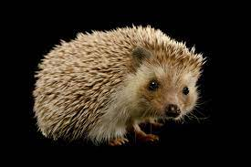
Music
- Sing nursery Rhymes
- Harvest Festival songs
- Number Songs
- Sound matching games
- Investigate different instruments
Oak Academy
Maths
- Early Mathematical Experiences
- Pattern and Early Number
- Numbers within 6

Numberblocks.

KIRFS- I can recite the number names in order to 10

Number Rhymes and songs

R.E.
DCC Syllabus
Believing-
Which stories are special and why?

Please remember to bring to school:

- Your book bag.
- A water bottle.
- Come in your P.E kit on Tuesdays

Physical
- Large mark making – big brushes and water
- Ride different bikes, scooters
- Large equipment – balance, over and under
- Hope, skip and jump.
P.E
- Mixed Key stage wellbeing

Literacy
- Mark making / pencil control
- Re-tell familiar stories
- Little Wandle Phase 2
- Write their own name
- Start to hear initial sounds

Class Reads

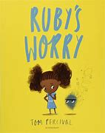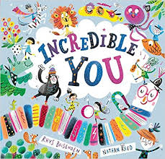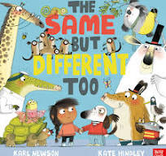

PSE
- See themselves as unique, share their interests and hobbies
- Role Play – familiar stories (tuff tray)
- Talk about themselves, feelings, family, environment around them.
- New Beginnings

