Curriculum Knowledge Plan – KS2 Cycle D
Themes | Autumn |  |  |  |  |  |  | Spring |  |  |  |  |  |  | Summer
Themes | Identity and Diversity |  |  |  |  | Peace and Conflict |  | Our World and Beyond |  |  |  | Saving Our Environment |  |  | Our Heritage |  |  | Social Justice
Key texts - Badgers | POSSIBLE ARTEFACT BOX?  Badgers  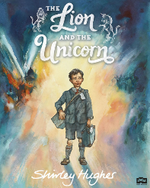  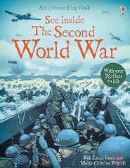 |  |  |  |  | 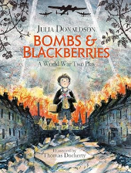 |  | TRIP TO SPACE CENTRE  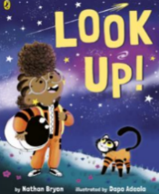  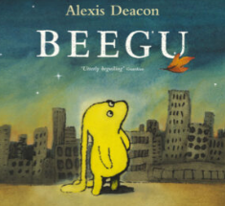 |  |  |  | 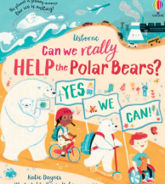  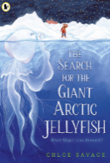 |  |  | LOCAL FIELDWALK  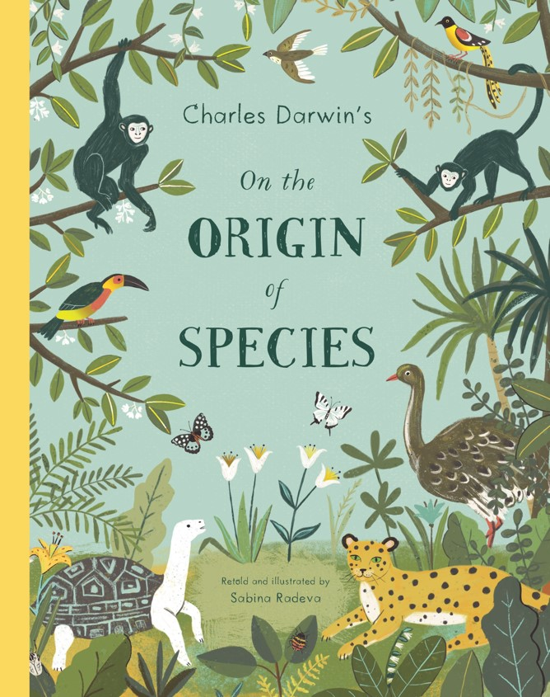  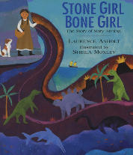 |  |  | 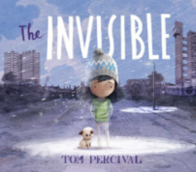  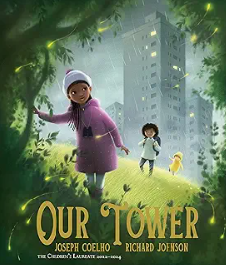  MAYAN DAY – HISTORY VAN
Key texts - Owls | 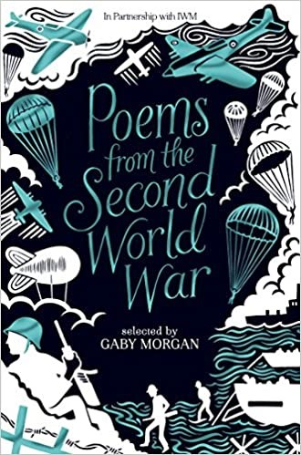  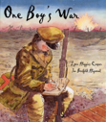  Owls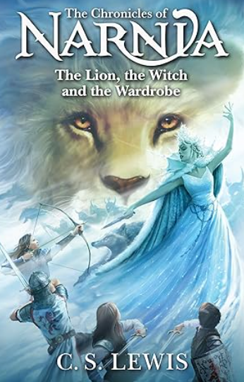 |  |  |  |  | 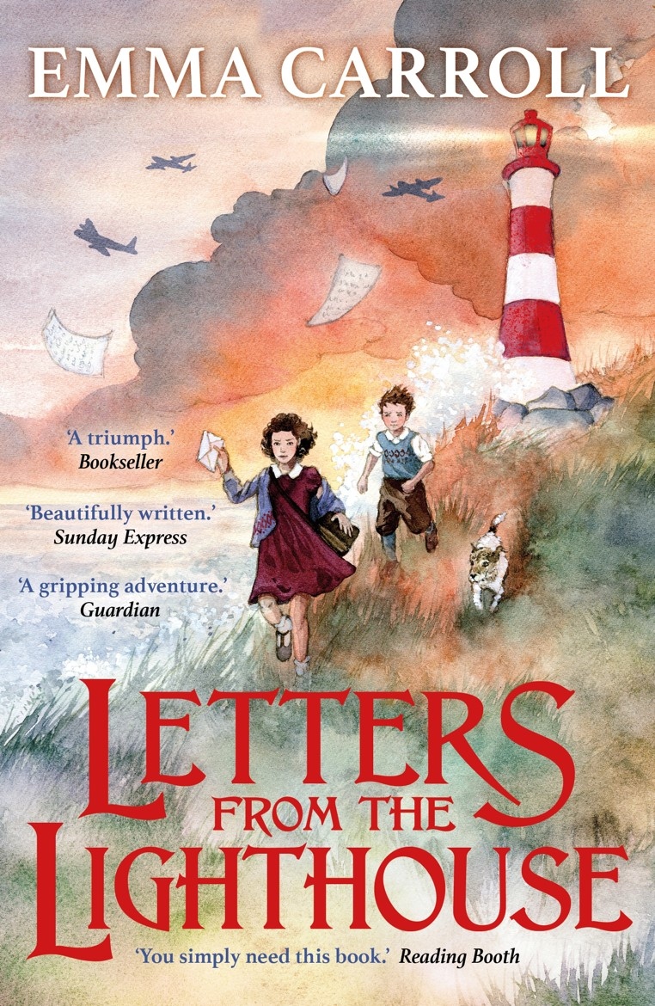  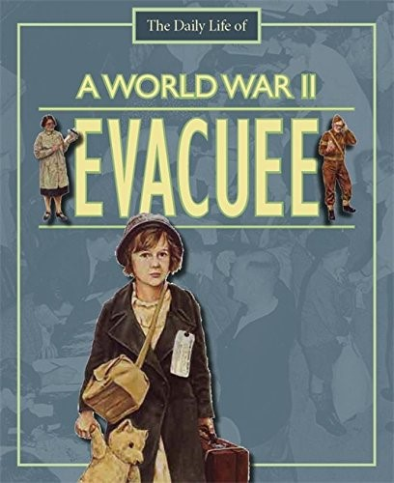 |  | 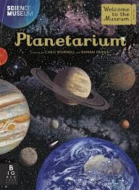  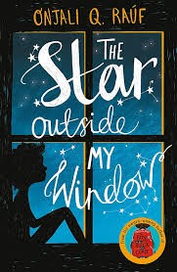  TRIP TO SPACE CENTRE |  |  |  | 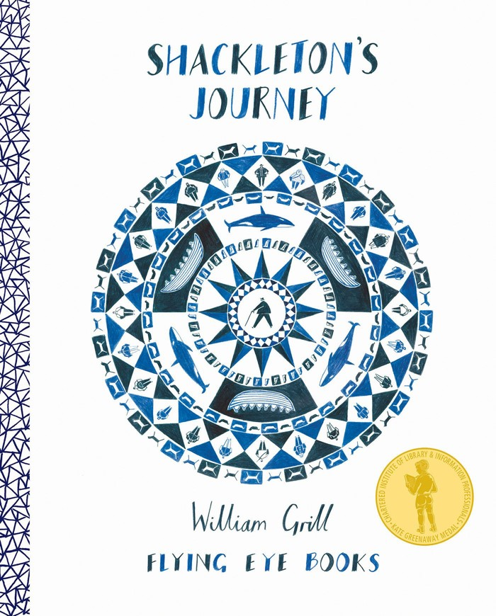  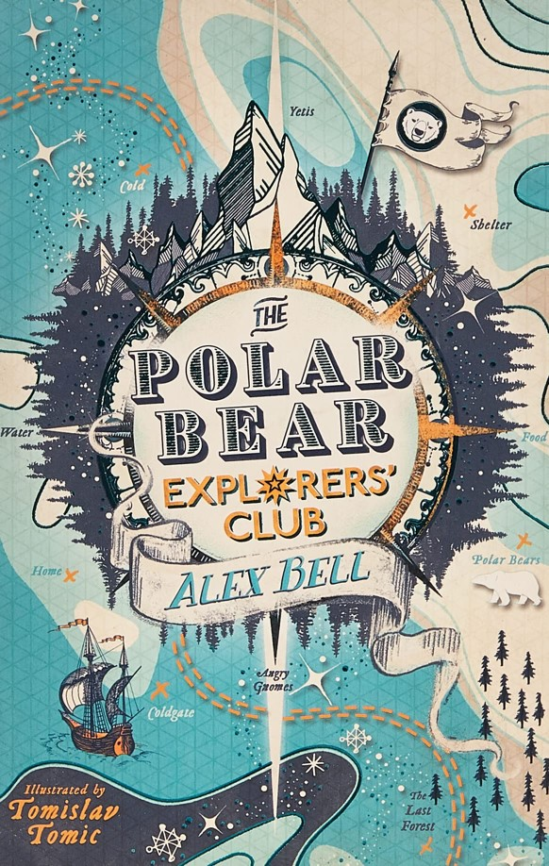 |  |  | 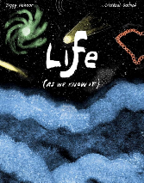  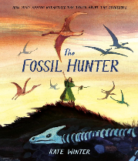  LOCAL FIELDWALK |  |  | 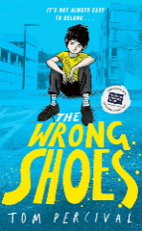  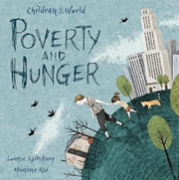  MAYAN DAY – HISTORY VAN
Purpose | Non-Fiction: Inform  Entertain: Poetry |  |  |  |  | Fiction: Entertain |  | Fiction: Entertain |  |  |  | Non-Fiction: Inform |  |  | Non-Fiction: Inform |  |  | Non-Fiction: Discuss  Entertain: Poetry
Genre | Entertain  Narrative  Description  Poetry |  | Inform  Explanation  Recount  Biography  Newspaper  Report  Essay | Persuade  Advert  Speech  Campaign |  |  | Discuss  Argument  Review  Debate | Entertain  Narrative  Description  Poetry |  | Inform  Explanation  Recount  Biography  Newspaper  Report  Essay | Persuade  Advert  Speech  Campaign |  |  | Discuss  Argument  Review  Debate | Entertain  Narrative  Description  Poetry |  | Inform  Explanation  Recount  Biography  Newspaper  Report  Essay |  | Persuade  Advert  Speech  Campaign |  | Discuss  Argument  Review  Debate
Themes |  | Autumn |  |  |  |  |  |  | Spring |  |  |  |  |  |  | Summer
 |  | Identity and Diversity |  |  | Peace and Conflict |  |  |  | Our World and Beyond |  |  |  | Saving Our Environment |  |  | Our Heritage |  |  |  | Social Justice
Maths |  | Place value  Addition & subtraction Statistics |  |  | Multiplication & division  Measurement – perimeter & area |  |  |  | Multiplication & division Fractions |  |  |  | Decimals & percentages  Algebra Ratio |  |  | Decimals  Geometry – properties of shape and position &  direction |  |  |  | Measurement – converting units and volume
Science |  | Light  BIG Question: Why does my shadow change length over the course of a day? |  |  | Electricity  BIG Question: Can we vary the effects of electricity? |  |  |  | Earth and Space  BIG Question: Sun, Earth & Moon: What is moving and how do we know? |  |  |  | Living things and their habitats  BIG Question: In what ways can we classify living things? |  |  | Evolution & Inheritance  BIG Question: What is evolution, how does it happen and how do scientists know? |  |  |  | Animals, including humans  Stages of growth in humans  to old age.  The impact of diet, exercise, drugs and lifestyle on health.  BIG Question: Why and how does the human body change over time?
History |  | Key Question: What was the impact of WW2 on the people of Britain? |  |  |  |  |  |  | Unheard histories  Big Question: Who should go on the banknote?  (History Day) |  |  |  |  |  |  |  |  |  |  | Big Question: How did the Maya civilisation compare to the Anglo-Saxons?
Art |  | Sculpture & 3D-Interactive Installation  Mon/Fri |  |  |  |  |  |  |  |  |  |  | Craft & Design-Photo opportunity |  |  | Painting & Mixed Media- Artist study
Geography |  |  |  |  | Where does our energy come from?  Mon/Fri |  |  |  |  |  |  |  | Would you like to live in the desert?  Mon/Fri |  |  | Can I carry out an independent fieldwork study?

Themes | Autumn |  | Spring |  | Summer
Themes | Identity and Diversity | Peace and Conflict | Our World and Beyond | Saving Our Environment | Our Heritage | Social Justice
DT |  | Electrical Systems – Steady hand game | Mechanical Systems – Automata toys / motorised moon buggy (wheels and axles)  Electrical  Systems (circuits with switches, motors) |  |  | Cooking & Nutrition: Developing a recipe  Design & make a healthy shortcrust pastry turnover – savoury
Comp | Online Safety – 2BeSafe | Online Safety – 2BeSafe  Year 1 - Introduction to Purple Mash  Year 3 - Email | Year ¾ Coding  Online Safety – 2BeSafe | Online Safety – 2BeSafe | Year 4 - Animations  Online Safety – 2BeSafe | Online Safety – 2BeSafe
Music | Preparation of songs for Church Family Service  Songs of World War 2  (Y5/6 Cycle A Kapow) | Preparation for Christmas production. | Preparation of songs for Church Family Service | Preparation of songs for Church Family Service  Film Music  (Y5/6 Cycle A Kapow) | Preparation of songs for Church Family Service | Preparation of songs for Church Family Service  Composing and Performing a Leavers Song  (Y5/6 Cycle A Kapow)
PE | Net & wall games  Tennis  OAA  Swimming | Dance  OAA  Swimming | Gymnastics  Movement  OAA | Invasion games  Tag rugby  OAA | Striking & Fielding Games  Cricket  OAA  Swimming | Athletics  OAA  Swimming
PSHE & RSE | Being Me | Being Safe | Money Matters | Growing Up | Changes | Drug Education
MFL | Spanish | Spanish | Spanish | Spanish | Spanish | Spanish
RE | Believing  DAS U2.3 What do religions say to us when life gets hard? – link to Judaism | Salvation  UC2B.7 What difference does the resurrection make to Christians? | Salvation  UC2B.7 What did Jesus do to save human beings? | Living  DAS U2.7 What matters most to Christians and Humanists? | Believing  DAS U2.1 Why do some people believe God exists? | Living  DAS 2.2 What would Jesus do? Can we live by Jesus in the 21st century?

